Self Care: Sleep

and Academic Success
Presented by Blanca Robles, M.S., CRC, LPC-S

Little importance is given to something so wonderfully replenishing and invigorating, such as

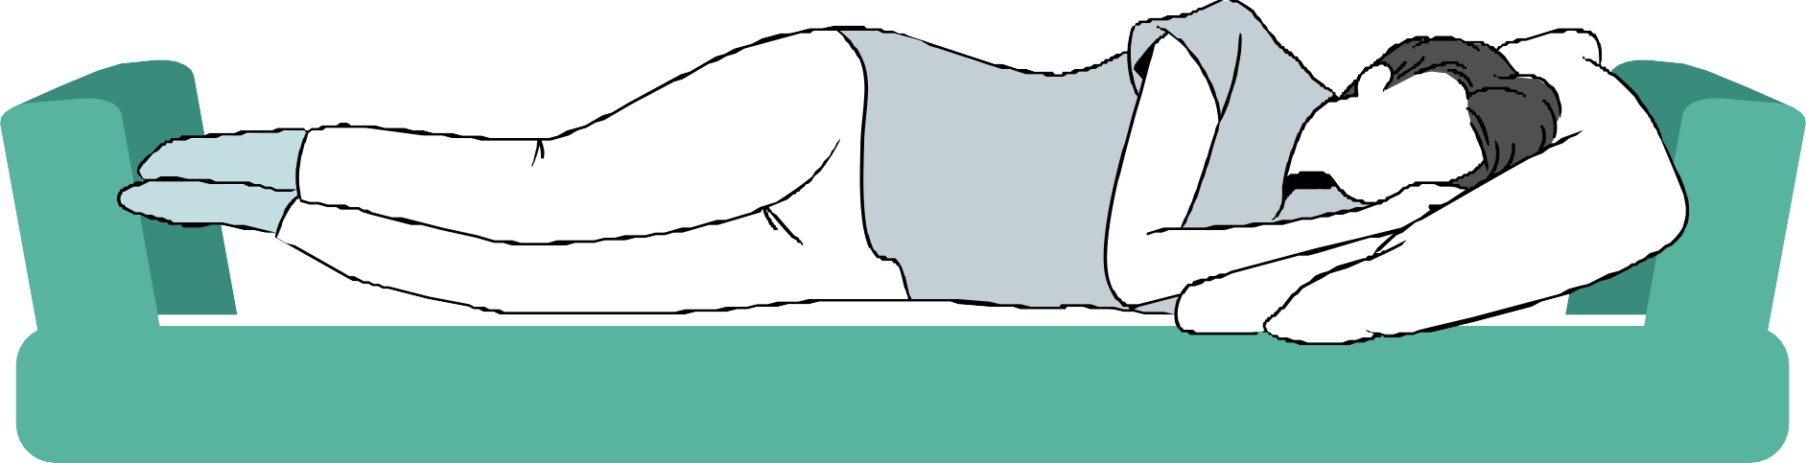
Sleep

There is a strong connection between our mind and our body

Therefore, the American Psychological Association, in its article "Stress in America" (2015), states that, "Physical self-care includes how you're fueling your body, how much sleep you're getting, how much physical activity you are doing, and how well you care for your physical needs. Attending appointments, taking medication as prescribed, and managing your health are all part of good physical self-care".

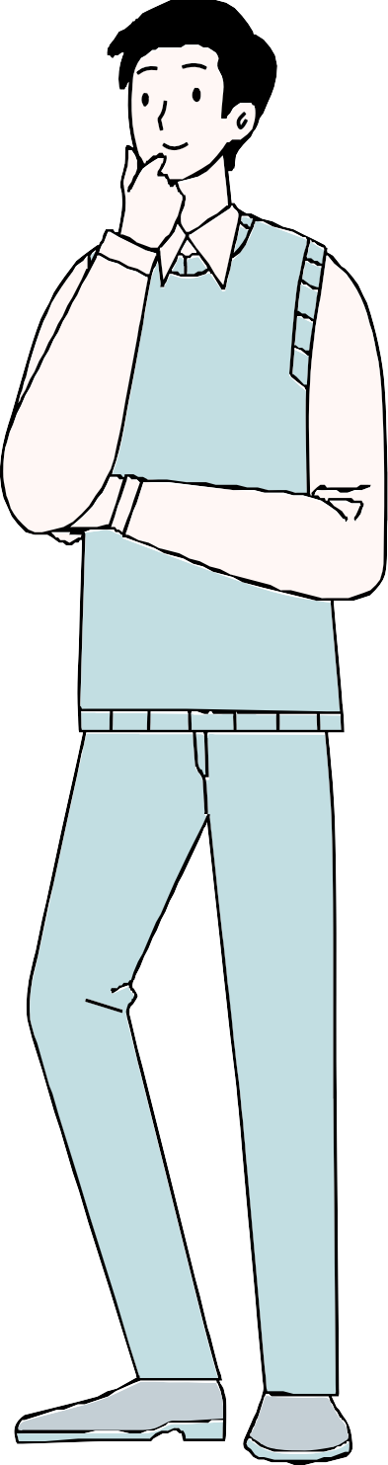
Let's start with honest answers to a few important questions

Do you sleep the suggested 7 hours?
Do you fall asleep within 20 minutes of going to bed?
If you wake up in the middle of the night you immediately go back to sleep? Do you keep your electronics (phone, tablet, laptop) outside the bedroom?
Do you oversleep?
Do you find yourself sleepy in the middle of the day?

If your answers were split, it is expected but not OK.

According to the American Academy of Sleep Medicine (AASM)

REASONS FOR POOR SLEEP AMONG COLLEGE STUDENTS

increased part-time working hours, having two jobs,
family/children responsibilities, pulling all-nighters to finish a paper, cramming for an exam,
going out during the week., watching TV/playing video games and connecting to social media.

SHORT TERM CONSECUENCES

According to Dr. Lawrence Epstein, MD, medical director of Sleep Health Centers in Brighton, Mass., an instructor of medicine at Harvard Medical School,
"After two weeks of sleeping six hours or less per night, students feel as bad and perform as poorly as someone who has gone without sleep for 48 hours."

LONG TERM CONSEQUENCES

Clete A. Kushida, MD, Ph.D, associate professor in the Department of Psychiatry and Behavioral Sciences at Stanford University Medical Center, an attending physician at the Stanford Sleep Disorders Clinic, says that "Sleep loss leads to learning and memory impairment, as well as decreased attention and vigilance."

Watch these informative videos

THE BENEFITS OF A GOOD NIGHT SLEEP - SHAI MARCUS

WHAT WOULD HAPPEN IF YOU DIDN'T SLEEP? - CLAUDIA AGUIRRE

Evidence continues to pile up

Hershner and Chervin, in “Causes and consequences of sleepiness among college students” in 2014, stated that college students who pull “all-nighters” are more likely to have a lower GPA, and those with insomnia have significantly more mental health problems than college students without insomnia.
Students who stay up late on school nights and make up for it by sleeping late on weekends are likelier to perform poorly in the classroom.
This is because, on weekends, they are waking up at a time that is later than their internal body clock expects. The fact that their clock must get used to a new routine may affect their ability to be awake early for school at the beginning of the week when trying to revert to their early rising habit.

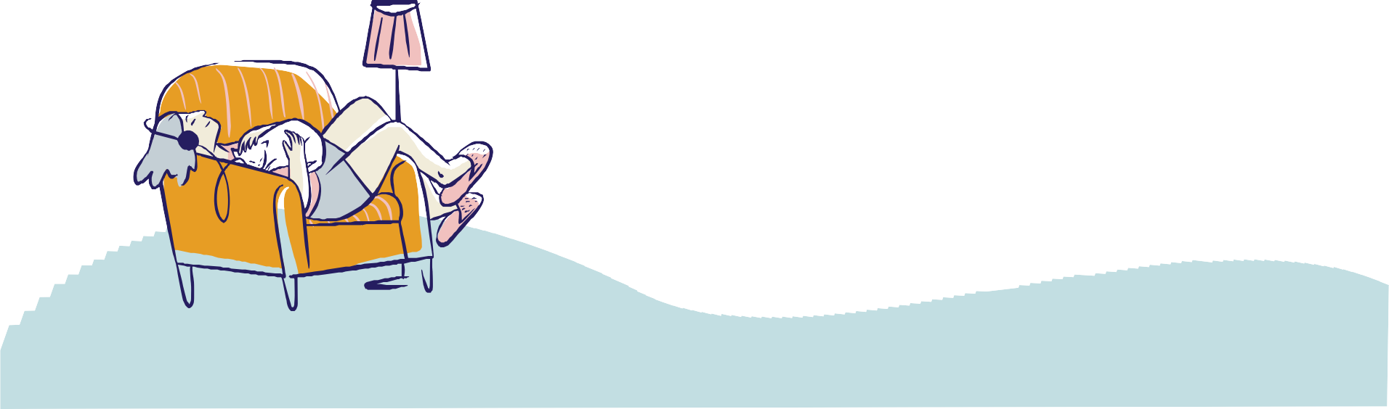

What to do?

TIPS AND IDEAS

GO TO BED EARLY - Start by going to bed an hour earlier in 30-minute increments as you become used to it.
LIMIT NAPS - If necessary, nap for less than an hour and never after 3:00 p.m.
WAKE UP ON WEEKENDS - It is best to go to bed and wake up at the exact times on the weekend as you do during the school week to avoid disrupting the pattern.
AVOID CAFFEINE - In the afternoon and particularly at night (switch for warm milk or herbal tea)
ADJUST THE LIGHT - Let the daylight in, and at night, dim the lights to let your body know it is nighttime and you will be going to bed soon (computer and phone included).
WIND DOWN - Get away from the computer or phone 30 minutes before going to bed and leave them out of the bedroom.
SHOWER - Take a warm shower or bath to help your body relax and eliminate the day's stressors.
FOOD - Avoid a large meal before bedtime, and only have a light snack to avoid going hungry.

Sources
2015 Stress in America Snapshot (apa.org)
Causes and consequences of sleepiness in college students https://www.ncbi.nlm.nih.gov/pmc/articles/PMC4075951/

Hershner SD, Chervin RD. Causes and consequences of sleepiness among college students. Nat Sci Sleep. 2014 Jun 23;6:73-84. doi: 10.2147/NSS.S62907. PMID: 25018659; PMCID: PMC4075951.
Healthy Sleep Habits - Sleep Education by the AASM
Sleep deprivation could affect academic performance of college students (news-medical.net)

Time to Reflect and Discuss among Peers

