Self-Care: Exercise
and Academic Success
Presented by Blanca Robles, M.S., CRC, LPC-S

Exercise can make you feel happier and reduce anxiety

Interestingly, it doesn’t matter how intense your workout is. It seems that your mood can benefit from exercise no matter the intensity of the physical activity.
One study found that six weeks of regular exercise reduced feelings of fatigue. This is something you would consider to be the opposite, but the more you exercise, the more motivated you feel, your days are more productive, and you end up looking forward to your next bike ride, stroll at the park, or visit to the gym.

A few questions needing an honest answer

Does fitness play an important role or part in your life? Do you make exercise a priority?
Do you make a point of moving around during the day?
Do you park as far as means to include more steps in your day? Do you take the stairs to include more steps in your day?
Do you have supportive friends or family that encourage exercising? Do you have a friend or family member who can be considered a fitness role model?

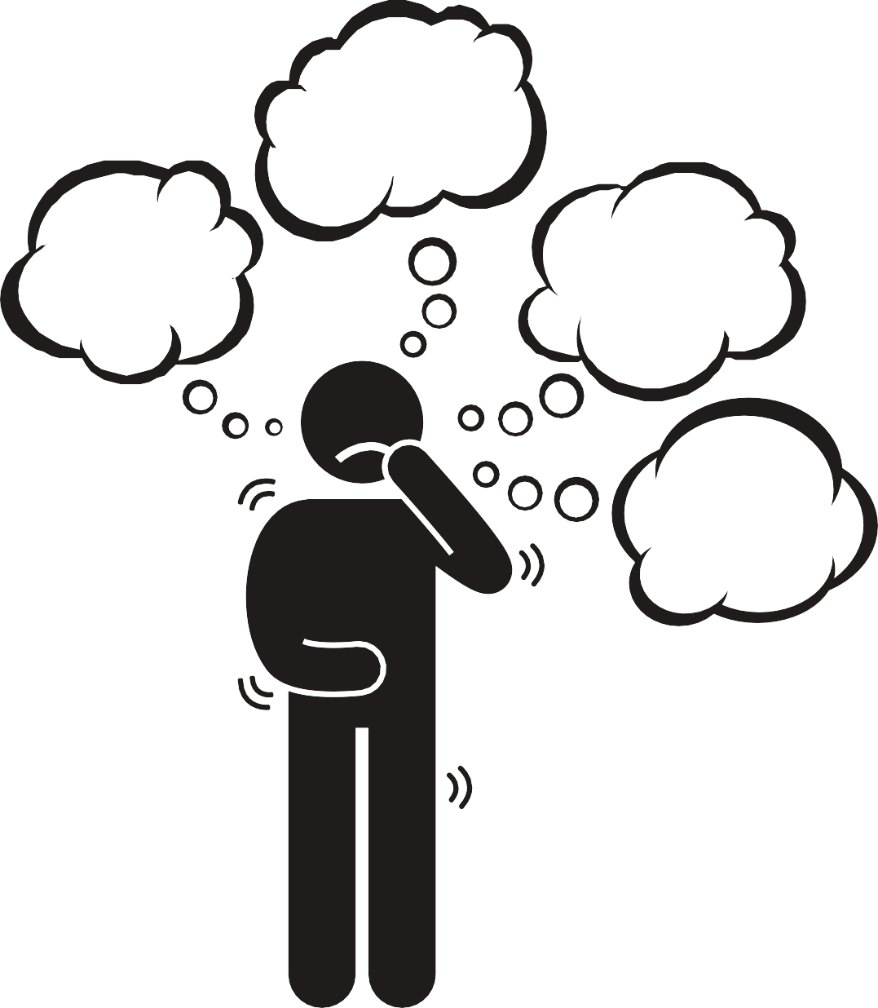
If you answered NO to any of them, it is expected but not OK.

If you are ready to change those answers, you are prepared to start making some changes. Keep in mind, any change, even the small ones, within time will give you positive results.

According to Harvard Health

BRAIN FUEL

Exercise increases glycogen levels, focused cognition, and clear memory.
BRAIN SIZE

Regular exercise increases the size of the hippocampus, associated with learning and cognition.
CHEMICAL BALANCE

Exercise increases blood flow to the brain, which helps grow blood vessels and release chemical growth factors.

Watch this informative video

Wendy Suzuki: The brain-changing benefits of exercise | TED

What to do?

TIPS AND IDEAS

FIRST THING IN THE MORNING - Exercising as soon as you wake up ensures you will not be too tired later on to get it done
JOIN A TEAM - organize a group, even virtual, to support and make you accountable
WALK OR BIKE TO SCHOOL- avoid the stress that parking causes and arrive energized to class
LISTEN TO MUSIC- Exercising to your favorite tune makes time go faster; create an upbeat playlist to walk to and keep you motivated. PLAY FITNESS GAMES - are made to give an actual workout
TRY A FITNESS APP - Get inspired by fitness trackers and community
DRINK WATER - Drinking enough water can help boost your stamina. CREATE A WORKOUT SCHEDULE - Helps keep track of the group muscles worked
TAKE THE STAIRS - instead of waiting for the elevator...keep moving!

Sources

https://www.helpguide.org/articles/healthy-living/the-mental-health-benefits-of- exercise.htm
https://www.health.harvard.edu/blog/regular-exercise-changes-brain-improve- memory-thinking-skills-201404097110
https://www.sciencedaily.com/releases/2008/02/080228112008.htm

Time to reflect and discuss among peers

