Resiliency can be what help us overcome l ife challenges.

Self Care: Adjustment through Resilience

Presented by Blanca Robles, M.S., CRC, LPC-S

Shock:
Shock involves emotional and physical numbness lasting from a few hours to several days.

Denial:
Denial may last anywhere from three weeks to two months and is a defense mechanism that allows the implications of the new situation the person has
experienced to be gradually introduced. Denial only
becomes an issue when it interferes with the person' s l i fe,

The Adjustment Process

Anger/ Depression:
Anger and depression are common reactions to
changes in social treatment and status. The person
may experience several different emotions during this stage and grieve for the changes in their body image, function, loss of future expectations,

Adjustment/ Acceptance:
The stage of adjustment and acceptance does not
necessarily mean the person is happy about what they now experience. However, it allows for successfully
adapting new roles based on realistic potentials and l imitations.

The Adjustment Process

https://www.verywellmind.com/five-stages-of-grief-4175361

Adjustment for all
LOOK WITHIN

Many factors can leave us needing to adjust, such as loss of job, liberty, or independence, loss or separation from friends and family, loss of loved ones, loss of health, and a loss of sense of security. The health crisis made us all feel in many ways disabled, imprisoned, poor, alone, anxious, desperate, and deeply sad.

Together as one
STRONGER UNITED
Today, we can all relate a bit with everyone else in the U.S. and worldwide. We can look at everyone and feel profound empathy for what they may be still going through, as are we.

How are you?

How are you handling difficult situations at the moment?
How | are | you adapting | to | your f irst, second, third, or
last | year | in college?
How | are | you adapting | to | online learning?
How | are | you adapting | to | reduced
face- to- face interactions?
Are you truly doing your very best to get through it?
Are your expectations for yourself realistic at this time?
Have you or are you asking for help?

Take a piece of paper, answer, and reflect on these questions.

LOOKING AHEAD
NOWHERE
Ultimately, the key to “successful” adjustment is your attitude.

BEING AN OPTIMIST
TO GO BUT UP
A good attitude, although helpful, will still not prevent difficulties from shaking us and leave us unsteady yet not broken, which is an essential part.

Life Challenges

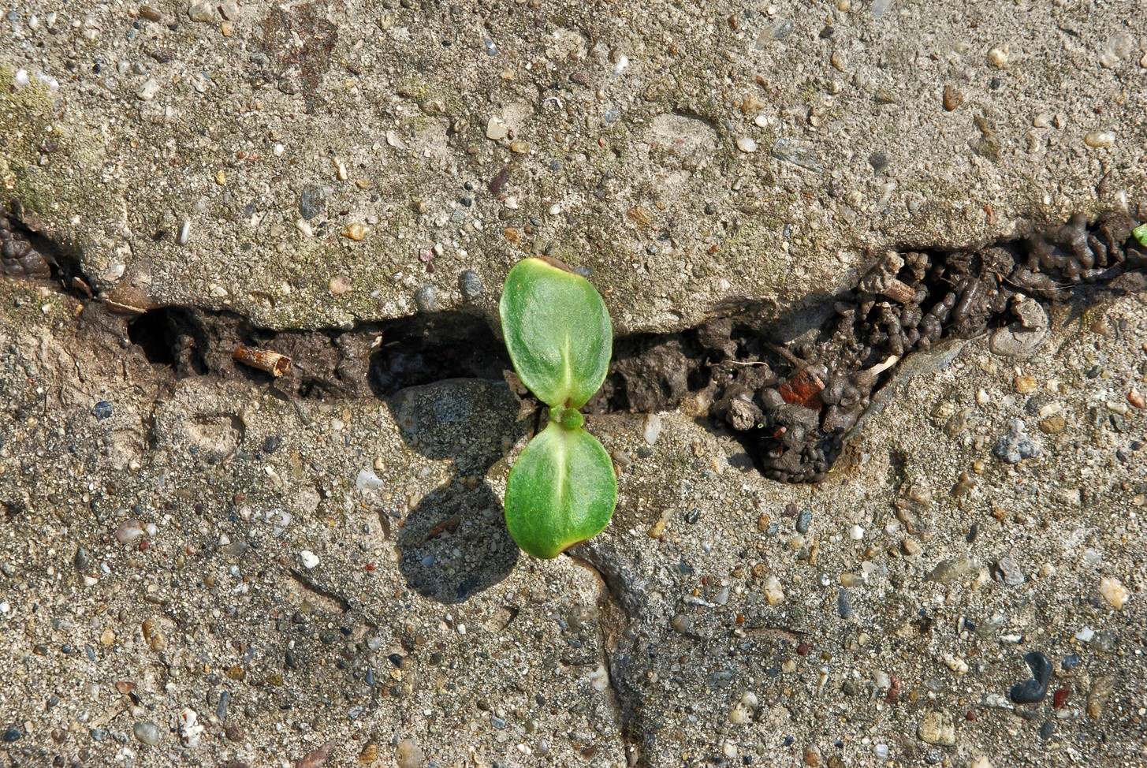
Resilience
The American Psychological
Association states that as much as resilience involves “bouncing back” from difficult experiences, it can also involve profound personal growth.

Resilience facilitates adjustment through greater psychological flexibility

https://www.apa.org/topics/resilience

Can we build resilience?
SELF CARE
Indeed, we are not born with high levels of resiliency; we acquire them through life and gathered experiences.

An article in Psychology Today highlights that individuals with high self-awareness and self-connection tend to be the most resilient people on the planet.

Resilience should not be confused with stamina like the one you show training at the gym or running a marathon. It is not about not stopping or not quitting; it is about knowing our limits and taking time
USING EACH OTHER FOR SUPPORT
to replenish

Build it up

https://www.psychologytoday.com/us/basics/resilience

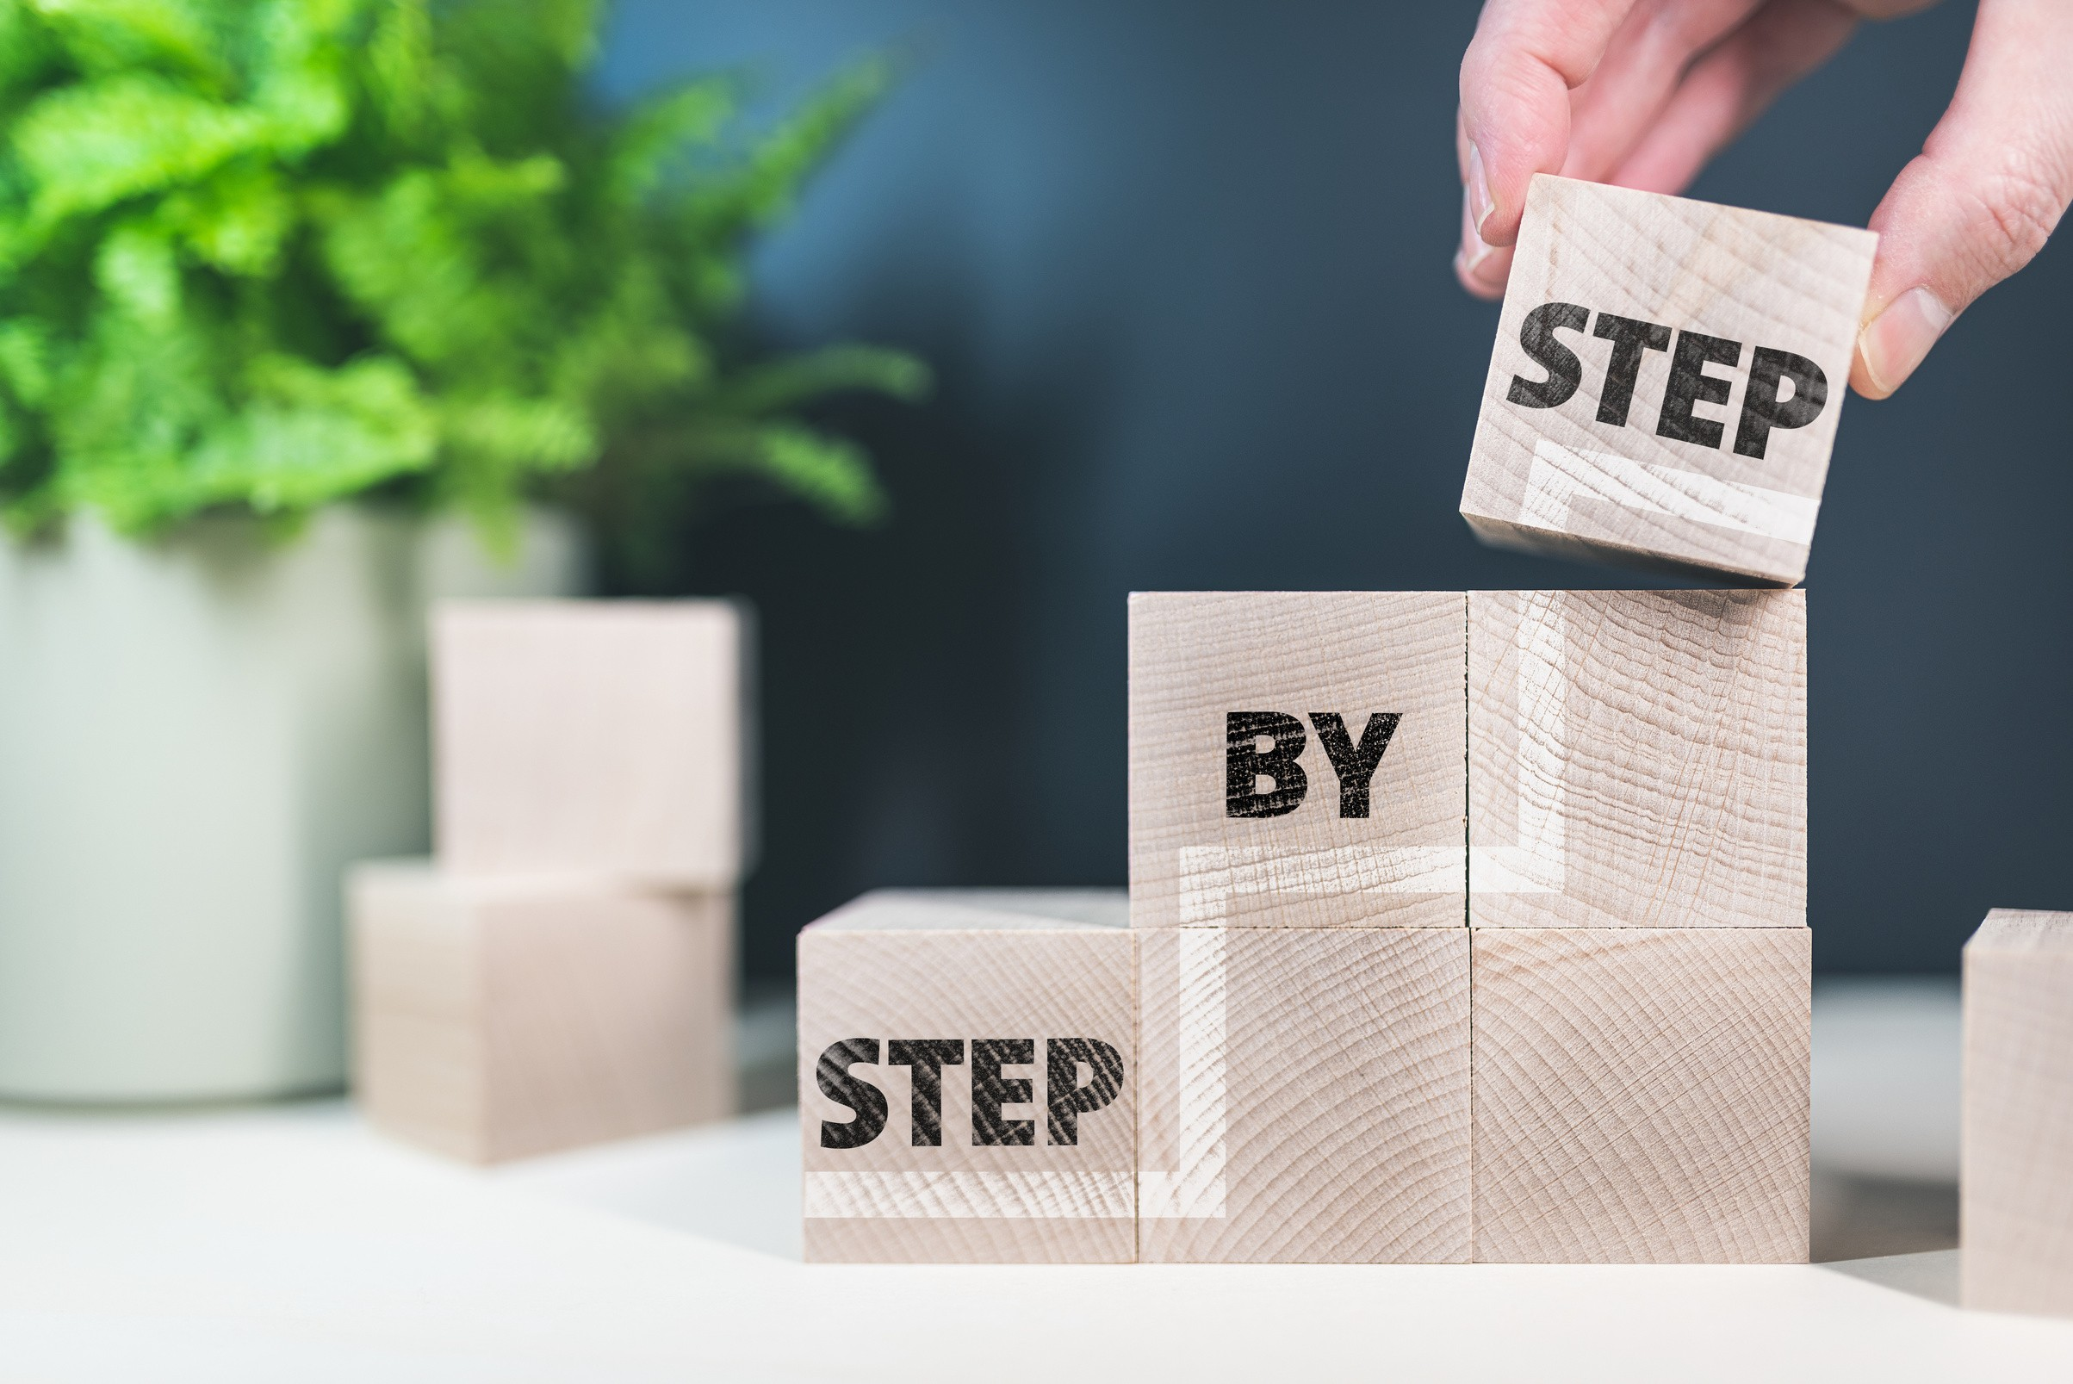
05

Building Resilience
Psychology Today: Resilience the power to overcome ,
adjust and persever

Accept that change is part
of l i fe; be f lexible

Acknowledge what you have accomplished; give yourself credit, even for the small
wins

Build a positive support network among family and
friends
Maintain presence by l iving in the now; it won' t get you stuck in the past or worry
about the future.

Feel accomplished by BReaking big projects into
small ones and complete
them

Practice communicating your feelings and emotions

Building Resilience
Psychology Today: Resilience the power to overcome ,
adjust and persevere.

Challenge your mind and
keep on learning

Find the positives in every
situation
Use key words, phrases or a song to help you stay
focused Maintain a healthy l i festyle

Practice gratitude and be
altruistic
Rest and restore

Stay focused on the things
you can control

Time to apply what you learned

Let' s take school and work, for example:

From the 13 steps or tips to build resilience select five and match them to specific
situations that are troubling you at the moment

Explain | how | their application | would | help | you
adjust f | aster | or better.

Take a piece of paper, answer, and reflect .

23

Remember, the
most simple things can bring the most happiness.
IZABELLA SCORUPCO

They are hopeful

They are grateful

They are authentic
Being happy does not mean
being trouble- free it is a decision.

The Traits of Resilient
and Happy
People

DO RANDOM ACTS OF
KINDNESS

VOLUNTEER AND HELP OTHERS

KEEP A
GRATITUDE JOURNAL

FORGIVE
QUICKLY, BUT WITH MEANING

EXERCISE
MINDFULNESS

BE
COMPASSIONATE

Right Here, Right Now
Let' s do this!

Please select at least three traits of resilient and happy people you would like to incorporate into your daily l i fe and commit to them.

You will keep building your resilience, which will help you adjust to college l i fe.

Keep the positive changes you have noticed since practicing these in your journal and share them
with those you would l ike to do the same.

Be Kind

Resilience | is | based | on | compassion | for | ourselves
as well as | co | mpassi | on | for others.

- Sharon Salzberg

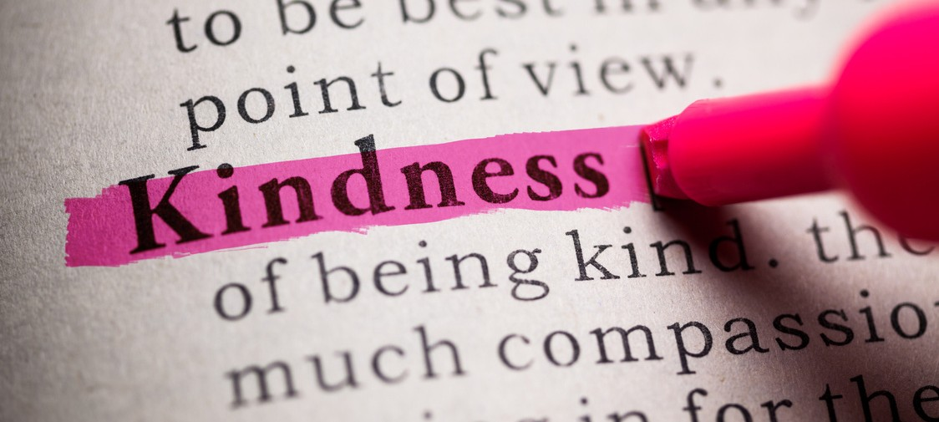

You Belong Here
I am glad you have stuck around and made it
through some tough times. College is not easy, but it is for you.

22

Sources
https:// www. verywellmind. com/ f ive- stages- of- grief- 4175361 https:// www. apa. org/ topics/ resilience
Psychology Today: Resilience is the power to overcome, adjust, and persevere

