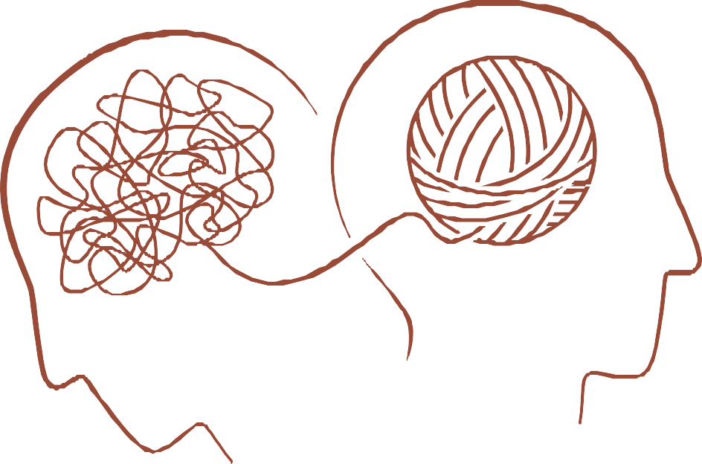

Emotional Health
and Academic Success

Presented by Blanca Robles, M.S., CRC, LPC-S

“One small crack does not mean that you are broken, it means that you were put to the test and you didn’t fall apart.”

― Linda Poindexter

The American College Health Association informs colleges that mental health needs are almost directly related to measures of academic success. For example, their 2015 survey found that students who reported psychological distress also reported receiving lower grades on exams and courses, getting an “incomplete,” dropping classes, or experiencing a significant disruption in thesis, dissertation, research, or practicum work.

Have
school-related matters brought up stress?
According to JJ Arnett in the article "Emerging Adulthood," in addition to stress related to academic load, students may have to face the task of taking on more adult-like responsibilities without having yet mastered adulthood's skills and cognitive maturity.
For example, many traditional college students may
meet potentially stressful experiences for the first time, including working, being in a significant relationship that may lead to marriage, or having roommates with cultures and belief systems different from their own.
Non-traditional college students who may be older are
often employed full-time and may have dependents.

“If you are depressed, you are living in the past.
If you are anxious, you are living in the future.
If you are at peace, you are living in the present.”
― Lao Tzu

Your years as a college student could be the best experience if you let it.
It is not uncommon to reminisce about the good times you had in high school or think of what sophomore, junior, or senior year will be like. However, many students can not wait to graduate; that is all they can think about and stress over.

Enjoy college time by being in the now (in the moment), participating in class, letting your voice be heard, making new friends (virtually or face to face), and attending campus events (athletics, performances, festivals).

Adjusting to a life-altering event as it is becoming a college student takes time.
Feeling nostalgic about home, friends, classmates, teachers, and coaches is normal.

This adjustment period may require eliminating stress, having social support, and seeking professional help.

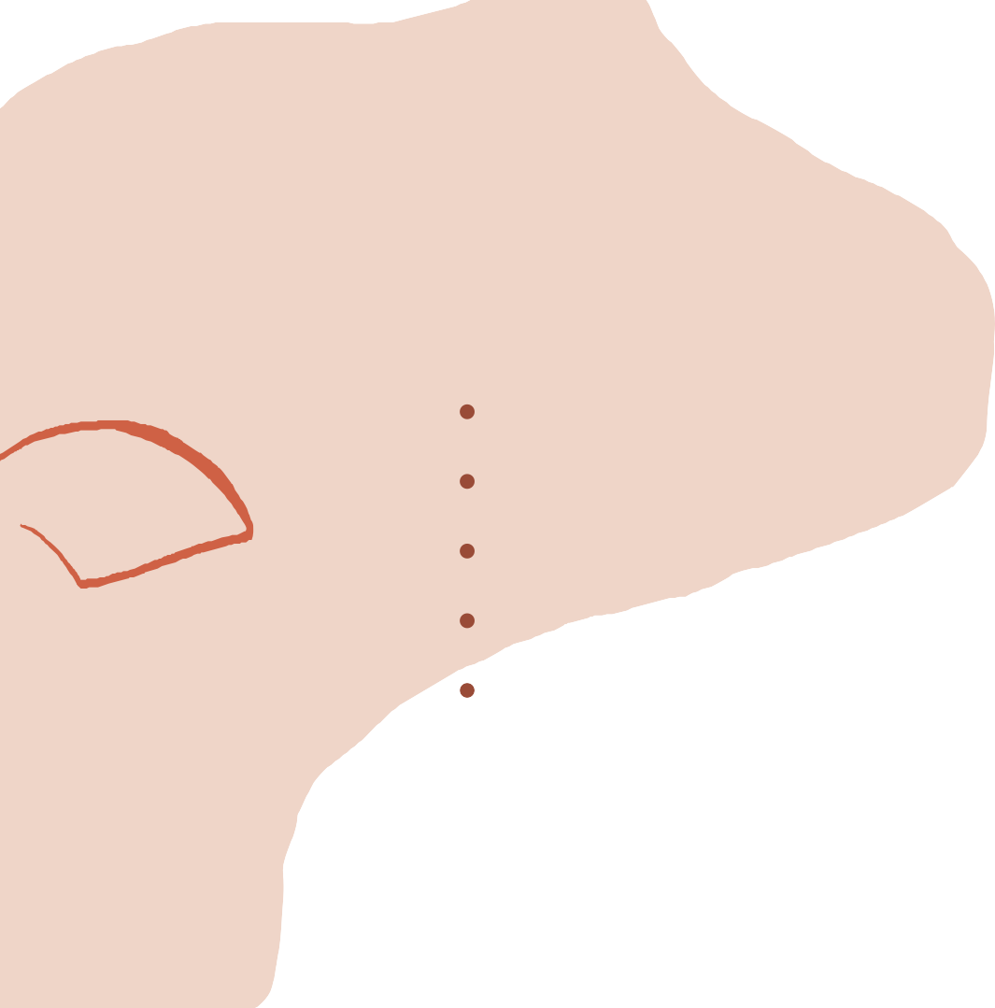

Are you still stressed?
When stress is emotional, you may help it by: Listening to music (creating a cheerful playlist) Practicing mindfulness (being present)
Talking to a friend (sharing thoughts and emotions)
Talking to a therapist (often found on campus) Writing in a journal (counting those things you are grateful for).
Stress can affect your health, sleep patterns, dietary choices, exercise routine, and relationships, so be on the lookout and take action.

Get organized and plan ahead
One way to reduce the stress you experience is to keep a minimalist environment, a soothing study area free of distractions and clutter.
This can help you lower stress levels, save time finding papers, and keep roommate relationships friendlier. It can also help if you organize your assignments and exams in a planner. You could see what is ahead and prepare. Keeping up with your reading also will help you feel at ease. Test prepping encourages more studying. Once the good grades start rolling in, you will be over the moon, feeling you can do anything. Your energy levels will increase, and you will feel good about yourself.

Other types of stress

Caregiver stress and work burnout

Take some time off, and find someone reliable to care for your kid(s) or family member, even for a few hours. Take a day off, request a vacation day, and plan things to do even if you are staying in town (staycation). If this is not enough or an option, you could:
Get a hobby, exercise, cultivate supportive
relationships, get more sleep, and lastly but most importantly, MAINTAIN A SENSE OF HUMOR

Humor as therapy is no laughing matter (lol).

This is why...According to Psychology Today, there are serious facts:

Researchers say children laugh about 300 times a day, adults perhaps 15 times a day.
The sound of roaring laughter is far more contagious than any cough, sniffle, or sneeze. Humor and laughter can cause a domino effect of joy and amusement.

“When you laugh, your mind, body, and spirit change” Mark Twain.

Laughter
The Mayo Clinic mentions that laughter reduces the stress chemicals in your brain and increases the amount of oxygen flowing through your brain and body, which is excellent for your mental health. Laughing can even turn a negative experience into a positive one and brighten your mood for the rest of the day.
Laughing alone is possible but best shared with
a friend

Often misunderstood or misdiagnosed
It is characterized by a marked persistent sadness (weeks then turn into months), not just having bad days.
Depression:
The loss of a family member
The end of a relationship (love or friendship) Being sick
The loss of a job
And many more can bring some sadness into our lives, which is normal. Not feeling sad about any of these events is more troubling. If you ever find yourself there, I want you to be patient; this will pass. However, if weeks become months and you have lost interest in things you enjoyed before and have no energy to do your daily activities, you may need help from a therapist. There is no need to feel embarrassed; life events and their emotional charge are best discussed with a professional.

How to begin the conversation when talking to a therapist

There is no right or wrong
Nothing is off limits; you can talk about everything in therapy. You may talk about your hopes, dreams, fears, disappointments, hurt, shame, parents, partners, and sexuality. No topic is off- limits if it is bothering you; bring it up.
Find it hard to remember
Keep a journal in preparation and take it to the appointment. Once in therapy, also keep track of your emotions in your diary and bring it along. Also, write down the practice your therapist suggests and the changes you have noticed to discuss in the next session.
Be honest
Please let your therapist know you are holding back until you feel comfortable. Once you build a foundation of trust, you will open up more. You can try hard to make it happen, but please be bold and look for someone else if that doesn't happen. It is essential to avoid forcing it when you cannot connect.

Sources

https://www.acha.org/documents/ncha/NCHA- II_WEB_SPRING_2015_REFERENCE_GROUP_EXECUTIVE_SUMMARY.pdf

Arnett JJ. Emerging adulthood. A theory of development from the late teens through the twenties. Am Psychol. 2000;55(5):469–80

https://www.helpguide.org/articles/mental-health/laughter-is-the-best-medicine.htm https://www.verywellmind.com/beat-depression-without-prescription-drugs-1065079

Time to Reflect

